*Margie’s Travel Presents…* **Dubai**

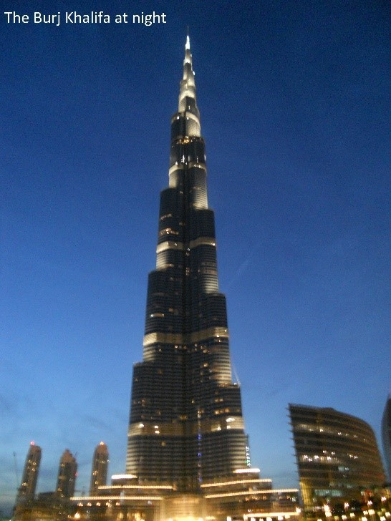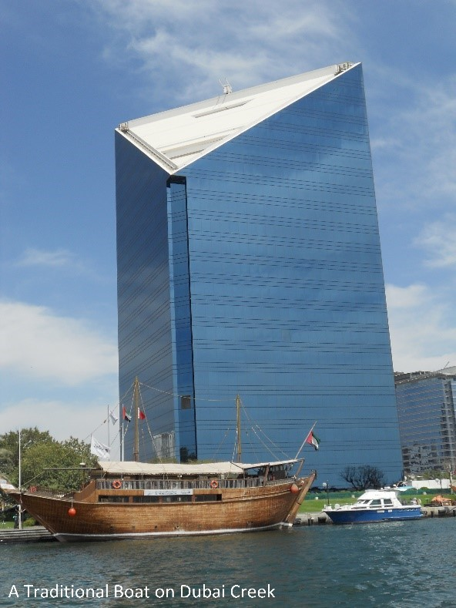Dubai is the largest and most populous city in the United

Arab Emirates. It is located on the southeast coast of the Persian Gulf and is the capital of the Emirate of Dubai, one of the seven emirates that make up the country. Abu Dhabi and Dubai are the only two emirates to have veto power over critical matters of national importance in the country's Federal Supreme Council. The city of Dubai is located on the emirate's northern coastline and heads the Dubai-Sharjah-Ajman metropolitan area.

**Dubai Hotels**

Margie’s Travel offers the following accommodation options in Dubai:

**The Creek Hotel**

Friendly boutique hotel within the heart of the bustling Dubai Creek area.

**The Deira Hotel**

Family-run hotel in Dubai’s traditional commercial center.

**The Lost City Hotel**

Luxurious accommodation in Dubai, with onsite waterpark and aquarium.

# To book your trip to Dubai, visit www.margiestravel.com